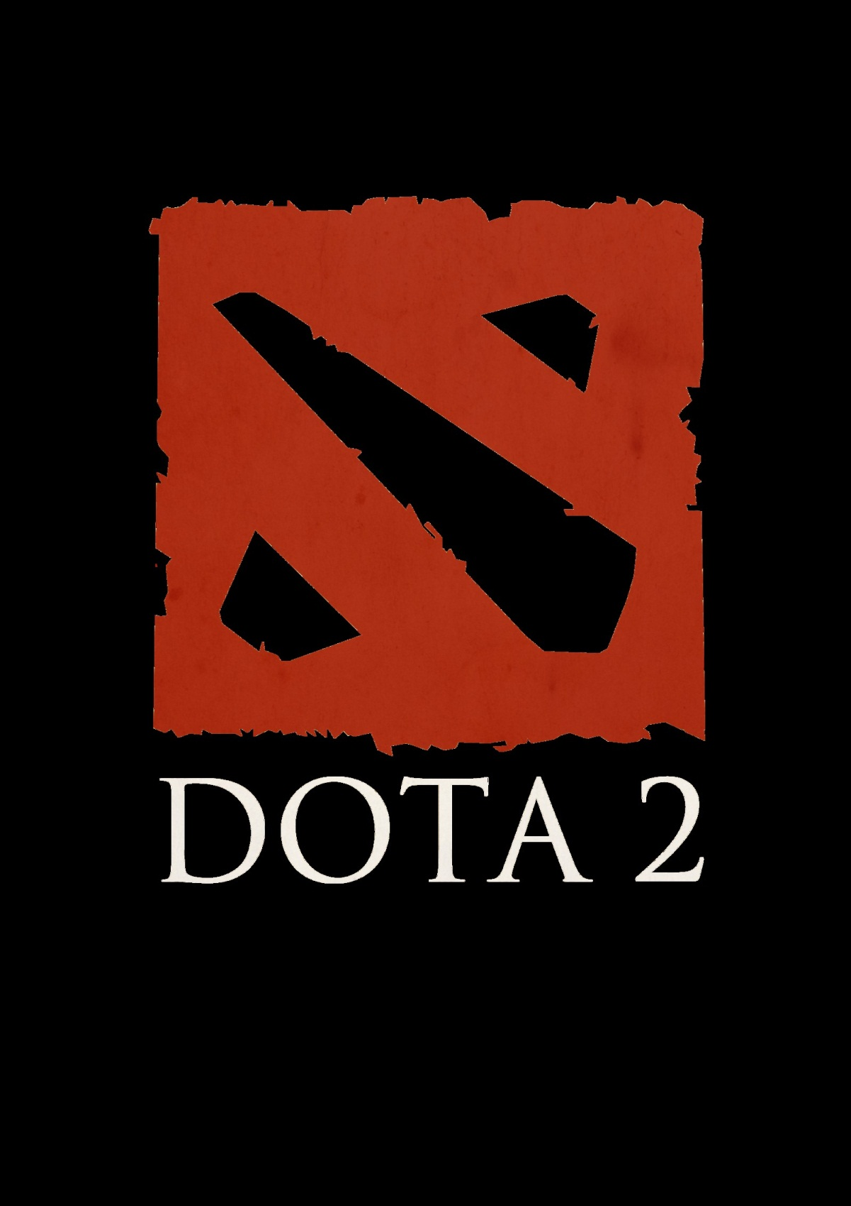

**Hero Guesser**

User Manual

Introduction:

Welcome to the Dota 2 Hero Guesser! This is a guessing program based upon the popular free-to-play action real-time strategy game DOTA 2 developed and published by Valve. This program plays a guessing game with the user using the hero roster of DOTA 2 and its 107 heroes.

Content and Instructions for Play:

Before one begins to play, one must at least partially familiarize themselves with the heroes of DOTA 2 or have a ready list of heroes and their attributes available. Included below is a link to the official DOTA 2 hero list for use when playing:

<http://www.dota2.com/heroes/>

One can also refer to the actual input text files within the game source code folder for all attributes used and for each hero’s individual attributes if the link proves insufficient.

When the game is run, after introductions, it will begin asking the user a series of questions. The user at this point should have a hero they are thinking about for the game to guess. The questions are designed for the computer to try and narrow down the options available to it and guess who the user is thinking of. The user should answer all of the computer’s queries with either a “yes” or a “no.” (“y” or “n” is also acceptable). Please ensure that your answers are in English as the game does not support other languages. At the end, either the computer will claim victory as it successfully guesses the hero the user is thinking of or the user can claim victory as they outwit the cold logic of the machine. However, we as the developers of this program can offer a brand promise to the users of this product that they will never be able to outwit the program fairly or your money back.

Conclusion:

We hope that you have a fun time with our product and we thank you for your purchase. Please kindly report any bugs found as we are constantly improving and updating our product and we wish to ensure the best possible experience for users. Thank you!

Developer Credits:

Qianshu Wang

Octavio Harris

Muneeb Ahmed